Perimeter
The perimeter of a closed shape is the distance around it, or the sum of the lengths of its sides/boundary.
Example 1: | Find the perimeter of an equilateral triangle with each side measuring 4 centimeters.  = 4 cm + 4 cm + 4 cm = 12 cm |  | 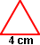
Example 2: | Find the perimeter of a regular pentagon with each side measuring 3 inches. | 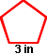
 | = 5(3 in) = 15 in
Area
Area is measured in square units, such as square inches, square feet or square meters. A square unit is a square where each side has a length of one unit.
The area of an object is the number of square units it takes to cover the object without any overlap. To find area, count the number of square units that have been covered.
https://www.khanacademy.org/math/pre-algebra/measurement/area-basics/v/introduction-to-area-and-unit-squares
Example:
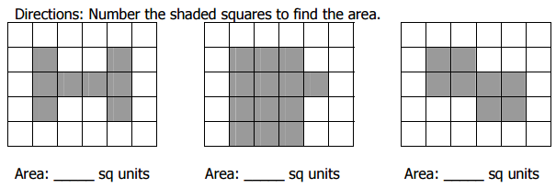

Areas of Common Shapes

Triangle: A three sided figure.
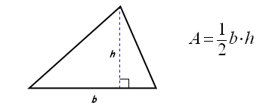

Relationship of sides to interior angles in a triangle
- The shortest side is always opposite the smallest interior angle
- The longest side is always opposite the largest interior angle
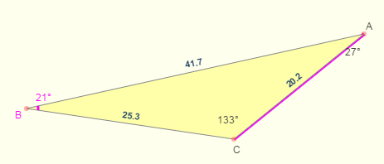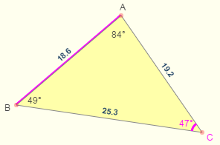

Triangle Inequality Theorem
- Any side of a triangle must be shorter than the sum of other two sides of the triangle.

Rectangle: A quadrilateral with four right angles.
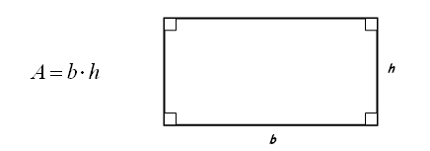

Parallelogram: A quadrilateral with two pairs of opposite sides parallel.
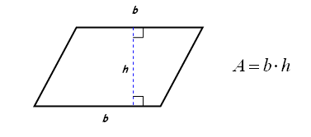

Trapezoid: A quadrilateral with exactly one pair of opposite sides parallel.
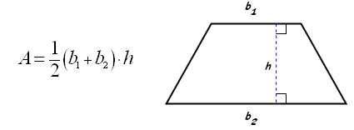

Area and Perimeter of Irregular Shapes
To find the area and perimeter of irregular shapes, the first thing to do is to divide the irregular shape into regular shapes that you can recognize such as triangles, rectangles, circles, squares and so forth...
Example—Find the area of this shape:
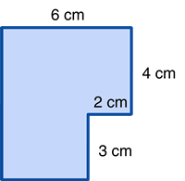
This can be done in two different ways:
Method #1 | Method #2
Divide the figure into two rectangles and find all missing lengths.  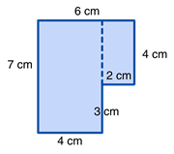  The larger rectangle has an area of  4 cm x 7 cm = 28 cm²  The smaller rectangle has an area of  4 cm x 2 cm = 8 cm²  If we combine these we will find the total area:  28 cm² + 8 cm² = 36 cm² | Draw two lines to make the figure into one large rectangle.  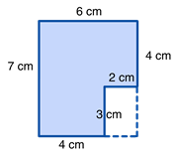  The area of the large rectangle is  7 cm x 6 cm = 42 cm²  However, a 2 cm x 3 cm rectangle is not included in our original figure, so we need to take out the area of the white rectangle (2 cm x 3 cm = 6 cm²)  42 cm² - 6 cm² = 36 cm²

Example #2—Find the perimeter of this shape:
Wait, some sides are missing! No problem, we can fill those by adding together or subtracting the opposite sides.
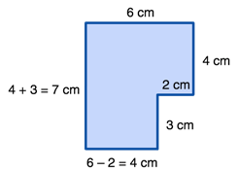
Now find the sum of all sides:

6 + 4 + 2 + 3 + 4 + 7 = 26 cm

Last Example—Find the area of this shape:
The figure above has three regular shapes. Starting from top to bottom, it has a triangle, a rectangle, and a trapezoid. Find the area for each of those three shapes and add the results
Area of the Triangle = ½ bh = ½ 3 x 4 = 6
Area of the Rectangle = length x width = 3 x 10 = 30
Area of the Trapezoid = ½ (b₁ + b₂) x h = ½ (3 + 5) x 2 = 8
Total area = 6 + 30 + 8 = 44 square units

